LESSON PLAN No.4
Subject: English
Form: VII
Date: 08.02.2017
Teacher: Păduraru Victor
Topic: Evaluation
Lesson type: Evaluation
Time: 45 min
Supervisor: Suceanu L.
Coordinator: Colodeeva L.

Specific competence:

Communicative Competence: Receipting writing messages (Reading)
Communicative Competence: Producing written messages (Writing)
Methodological Competence

Sub-competence:

S 3.5 producing written messages;
S 4.4 Editing short texts based on known topics;
S 6.3 Drawing pictures and collages in the course of learning activities.

Operational objectives:

Knowledge: Pupils will be able to name and describe a seaport city;
Application: Pupils will be able to illustrate a picture of the flag of USA and of UK.
Evaluation: Pupils will be able to explain why do they like their rooms.

NAME:__________________________ CLASS:

TEACHER: Paduraru Victor DATE:
Variant I

- Open the brackets using Present Perfect Progressive or Past Perfect Progressive:

1.My parents (to live)__________________________in this house since 1994.
2. When i came in, Maria (to look)__________________________for information about Stefan cel Mare for half an hour.
3. They (to decorate)__________________________their room since morning.
4. How long (to live)__________ you ___________________ in this apartment?
5.When my sister entered the house, I (to watch) __________________________ TV for 20 minutes.

2. Write the name of nationalities and languages of the following countries
Country | Nationality | Language
Republic of Moldova
England
The USA
France
Ireland

3.Describe one seaport city

4. Match the words with their definitions:

Concrete blocks of baked clay that are used for building walls
Brick a substance used for building and made from cement, sand, small stones and water
Stairs type of earth that is soft when it is wet and hard when it is dry
to whitewash a set of steps inside the building
clay to paint walls white with mixture of chalk and water

5. Describe your own room using new words from vocabulary.

NAME:__________________________ CLASS:

TEACHER: Paduraru Victor DATE:
Variant II

1.Describe one seaport city

2.Open the brackets using Present Perfect Progressive or Past Perfect Progressive:

1.My parents (to live)_______________________in this house since 1994.
2. When i came in, Maria (to look)______________________for information about Stefan cel Mare for half an hour.
3. They (to decorate)________________________their room since morning.
4. How long (to live)__________ you ___________________ in this apartment?
5.When my sister entered the house, I (to watch) _______________________ TV for 20 minutes.

3.What do you know about the United Kingdom

4. Match the words with their definitions:
Concrete blocks of baked clay that are used for building walls
Brick a substance used for building and made from cement, sand, small stones and water
Stairs type of earth that is soft when it is wet and hard when it is dry
to whitewash a set of steps inside the building
clay to paint walls white with mixture of chalk and water

5. What do you like and dislike referring to the place you live in (surroundings)

NAME__________________________ CLASS:
TEACHER: Paduraru Victor DATE:
Variant III
- Divide the parts of United Kingdom and write down their capitals and symbols.
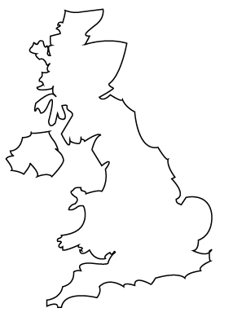

- Draw the USA Flag

- Draw the UK flag

